[1]

AMISR Array Antenna Patterns   
And Mutual Coupling Estimates

Adam R. Wichman, *Member, IEEE*

*Abstract*—This reports results from modeling the far field radiation patterns for various proposed configurations of the Advanced Modular Incoherent Scatter Radar (AMISR) phased array, ranging up to 4,096 cross half-wavelength dipoles in a 8x16 unit panel configuration presently installed at Poker Flat, Alaska. The boresight far field radiation was determined using the multi level fast monopole method (MLFMM), a variation on the method of moments, with the FEKO suite from EM Software & Systems. The normalized antenna radiation intensity and antenna patterns are compared to the analytical result from ideal element and array patterns, at two azimuthal orientations, taking the difference as a proxy for mutual coupling. In each case the idealized element and array pattern (without backplane) overestimates the far field radiation and normalized radiation intensity when the elevation drops 20 or more degrees from boresight. While the difference between the numerical solution and the ideal normalized radiation intensity can span up to 20 dB, however, given the high centerline gain this variation arises at points where the gain or radiation pattern amplitude has already fallen significantly (*e.g.,* more than 40 dB for the 1x32 array, more than 35 dB for the 8x16 array) from center-peak. Mutual coupling thus appears to have minimal impact on boresight operation, but may warrant further investigation for scanning angles approaching ~20+ degrees, depending on the array configuration under study.

*Index Terms*—AMISR, phased array, mutual coupling, FEKO.

# INTRODUCTION

T

HE Advanced Modular Incoherent Scatter Radar (AMISR) is a modular phased array for atmospheric research at 430-450 MHz. [1] The current array configurations include a 8x16 panel face in Poker Flat, Alaska and two faces in Resolute Bay, Canada, with ~ 1.1° beamwidth, an aperture ~ 715 m2, and gain ~ 43 dBi. [1]

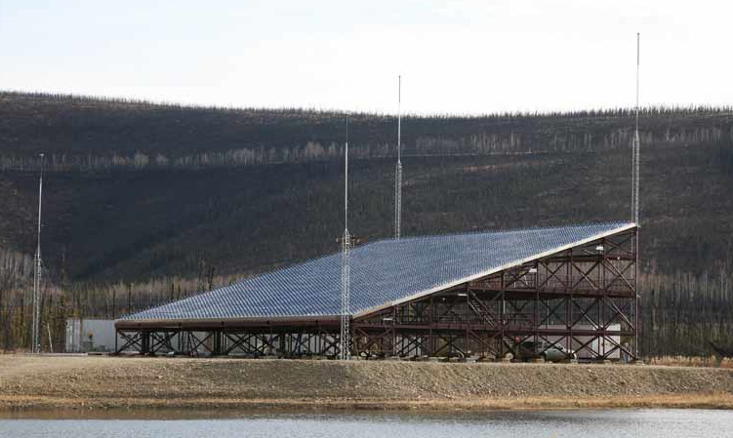

Fig. . AMISR Poker Flat installation.

Several other antenna configurations have been proposed. The antenna radiation and radiation intensity patterns, however, have not been definitively determined. As a result, it is not known how the predictive antenna pattern should be altered from the idealized case to account for mutual coupling. In this project we investigate the far field antenna and normalized radiation intensity patterns (“antenna power”) using numerical simulation to solve Maxwell’s equations for a realistic array model. Because the numerical solution includes mutual coupling, we can estimate the mutual coupling effects by comparing the numerical solution to the respective ideal antenna patterns.

For large arrays mutual coupling is generally addressed by assuming it affects scale but not pattern. In large arrays with elements spaced along a grid at regular intervals, the edge effects are ignored and the pattern distortion effect is a simple scaling of relative amplitude patterns while preserving the relative pattern shape. [2] In the AMISR case, we find that edge effects are insignificant within 20° of boresight but become increasingly noticeable at lower elevation for each configuration studied. The edge effects, however, correspond to reduced far field gain at low elevation where the gain has already fallen by a sizeable margin from the maximum. This result may matter to operations that steer the beam at or above θ = 20° from boresight elevation.

# Methodology

## Mutual Coupling

The dense AMISR antennas are subject to mutual coupling among the constituent dipole elements from radiation, electronic cross talk, and indirect scattering from proximate objects. This report considers the effects of radiative mutual coupling, in which each antenna radiates some portion of received signal to each other antenna element, and likewise receives radiation from each other antenna element as well as from the original source. [2, 3, 4, 5] The variation in the antenna currents results in variations in the element-wise input impedances as well as gain and the far field radiation patterns. The mutual coupling can also excite the polarization not directly excited by the signal source. [2, 3] In this project, we focus on the far field radiation pattern amplitude, without considering the detailed affects on element impedance or associated scattering matrix. Polarization data is available and could be the basis of further study.

## Antenna Pattern

Active impedance of an array element is difficult to measure and its availability for the proposed AMISR configurations unclear. [3, 4, 5, 6] In response to this general problem, several predictive numerical techniques have been developed to estimate far field patterns including mutual coupling. [3, 5, 6] By modeling the case of uniform element excitation this study conceptually follows the “average active-element model” insight that groups mutual coupling effects with an “average” antenna element pattern rather than in the element excitation current. [3, 4] We do not attempt to calculate an average element pattern, however, but simply compare the numerical model, with mutual coupling, to the ideal antenna pattern. In particular, we take the idealized cross half wave dipole antenna element radiation intensity as Ea=1 + cos2(θ), and model the array pattern as two interleaved rectangular arrays with 2 dx spacing and a dx, dy/2 relative offset. [3, 8] The ideal comparison does not account for reflection from the backplane.

In numerical antenna simulation the method of moments (MoM) takes mutual coupling into account when solving the applicable Maxwell equations. [3, 5, 6] While the MoM has been widely used in optimization and design analysis codes like NEC, the method is cumbersome for electrically large problems. [7, 10] A variation on the MoM formulation, the multipole fast monopole method (MLFMM), is better suited to far field calculations for large structures such as the various proposed AMISR configurations. [9, 10] Generally speaking, the MLFMM formulation uses characteristic basis functions and takes advantage of symmetry / sparsity in the matrix formulation for calculating the full-wave current-based solution of Maxwell’s equations. [*Id.*] The MLFMM solves the interaction between groups of basis functions rather than individual basis functions. [*Id.*] This provides more tractable N log (N) memory scaling, rather than N [log(N)]2 scaling with the method of moments formulation. [*Id.*]

Commercial antenna design software provides a MLFMM implementation. For this project we use the FEKO suite 6.3 from EM Software & Systems as the computer-aided design (CAD) package for antenna analysis. The numerical routines include a MLFMM solver. [9]

## CAD Testbed

The CAD model is assembled in FEKO using the array and element parameters provided by the AMISR operator SRI International. [1]

### AMISR unit panel

The AMISR unit panel comprises 32 cross dipoles in triangular configuration on roughly a 3.47 m x 1.98 m meshed aluminum backplane. [1] The AMISR operating range is 430 – 450 MHz, or free space wavelengths 67 – 70 cm. [1] The AMISR unit panel elements comprise crossed 34 cm long, 1 cm radius aluminum dipoles, or slightly less than half-wave at 450 MHz. [11] The crossed dipoles are situated 18 cm above the backplane, each with its own solid-state power supply. [11]

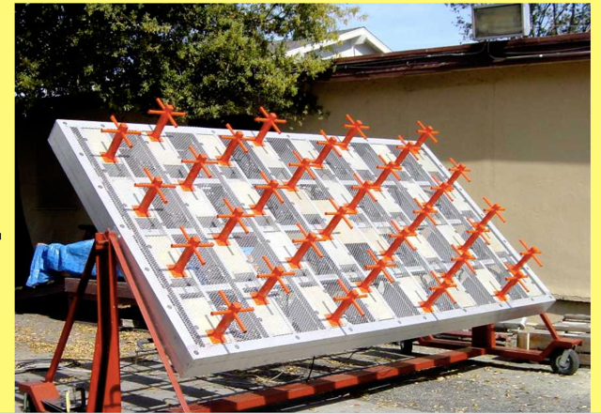

(a)

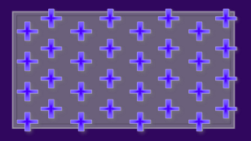

(b)

Fig. . (a) AMISR unit panel; (b) approximate AMISR unit panel triangular element configuration.

The long (x) axis element (column) spacing dx = 0.4343 m, while the short (y) axis element (row) spacing dy=0.4958 m. Every second column is (row) offset dy/2 relative to the prior column, so that the element row for each second column is located midway between the prior column rows. This allows us to model the unit panel as two interleaved, finite 4x4 arrays with the second array offset by (dx, dy/2) from the first. Notwithstanding the spacing adjustments available when combining unit panels into array configurations, as shown below, given the relative dipole length (34 cm) and y spacing (dy = 49.58 cm) this results in roughly 6 cm y-directed dipole overlap between panels.

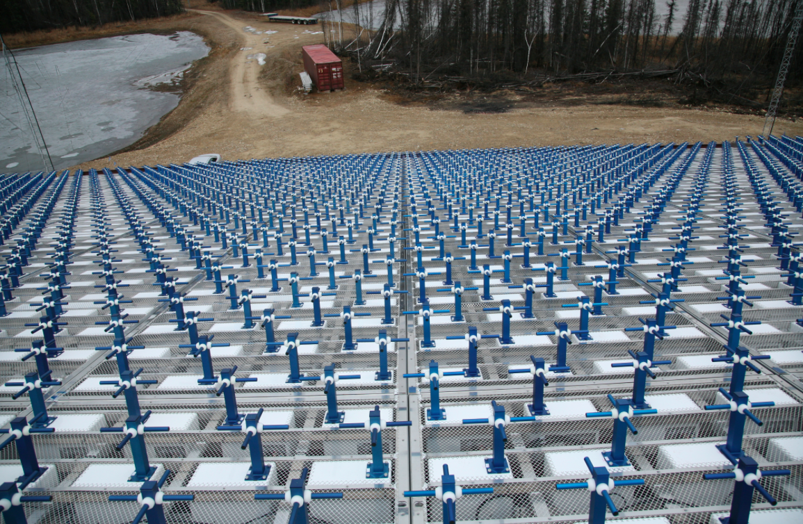

Fig. : y-directed dipole overlap between panels looking down face of 8x16 AMISR array at Poker Flat.

The dipole overlap in the AMISR arrays requires a finite array CAD model (*e.g.,* precludes modeling subsets of infinite arrays with periodic boundary conditions), and limits us to replicating core elements without associated finite ground planes. Nonetheless, the AMISR unit panel symmetry lets us generate a CAD model from a base configuration using two offset cross dipoles above an infinite, perfectly conducting ground plane.

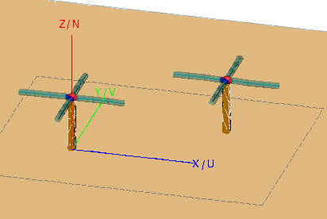

Fig. : Two-element AMISR unit panel base CAD model.

The dipoles are specified in aluminum using default material parameter files (*e.g.*, μr = 1, σ = 3.816e7 S/m) in FEKO, while the vertical post is treated as a perfect conductor. The dipoles and vertical post are electrically isolated. We separately excite the x and y oriented dipoles with ports on each element. The y-oriented dipoles are excited at a 90° phase offset from the x-oriented dipoles. Because we simulate boresight far fields, positional or steering phase offsets are not introduced in the excitation. The far field simulation uniformly excites each port by 1 V at 440 MHz with 50 Ω source impedance. The dipole impedance, of course, varies with mutual coupling in each element as numerically determined in simulation.

The AMISR unit panel is then modeled as a 4x4 finite array of the two-element CAD model, with x offset 2 dx and y offset dy.

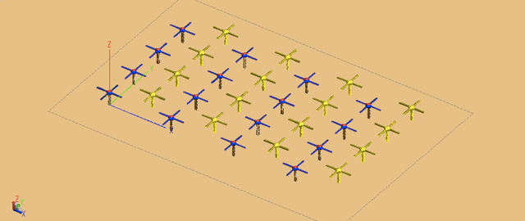

Fig. : AMISR unit panel CAD model.

The AMISR unit panel CAD model is scaled by m and n for m x-oriented panels, and n y-oriented panels to create the CAD model for a m x n panel array. The ground plane is imposed after scaling the two-element CAD model for the desired array configuration.

### Hardware

The FEKO suite 6.3 was installed on a 2.6 GHz Intel 64 bit processor with 256 GB RAM. Subject to the FEKO trial license, we used only 12 of 48 cores for the simulations. This proved sufficient for simulations up to 4,096 cross dipole elements. The primary limitation in data manipulation proved to be the graphical interface when formulating the test structure or formatting the far field data solution display, and this might be addressed in future simulations by scripting the CADFEKO or POSTFEKO operations or using a cluster with larger RAM.

## Simulation

We investigate the antenna patterns for three array configurations: 2x4, 1x32, and 8x16 panels. A 12x24 simulation was not completed due to hardware limitations.

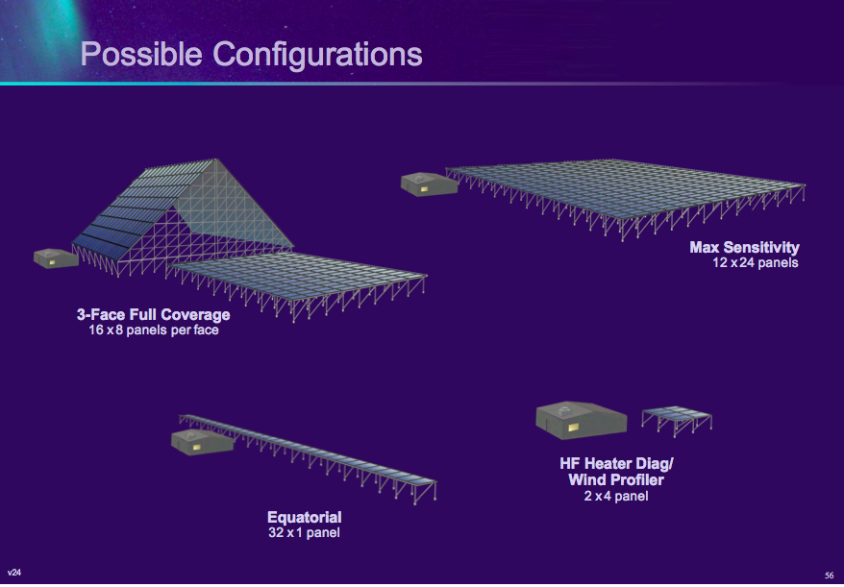

Fig. : AMISR antenna configurations.

The far field total gain and radiation pattern were solved in 3D in the half space above the ground plane for 440 MHz without taper. Given the tight 3dB bandwidth, sub-degree increments (0.1°) were chosen for the elevation angle {θ} in the 1x32 and 8x16 (but not 2x4) array configurations, while the azimuth {Φ} was solved at 1-5° increments. The results at Φ = 0, 90° are investigated, although the resulting far field simulation data spans the entire half-space above the ground plane.

Ideal antenna patterns for each given configuration were also computed, without ground plane, using Matlab (*see* Appendix, Section IV). [3] The difference between the numerical simulation in FEKO, and the ideal antenna pattern from Matlab, is taken as a proxy for mutual coupling in the antenna.

# Results

The simulation results are provided in the appendix (Sections I-III), and accompanying data files. The 8x16 simulations recover the published AMISR gain and beamwidth, suggesting reasonable agreement on boresight between the CAD model and the AMISR design specification. For exposition the 1x32 array results are considered more closely. As shown in Figs. 7 and 9, the ideal antenna power pattern (normalized radiation intensity) settles into a series of lobes with roughly constant max value greater than – 20 dBi (Φ = 0°) and -50 dBi (Φ = 90°) for |θ| > 30°.

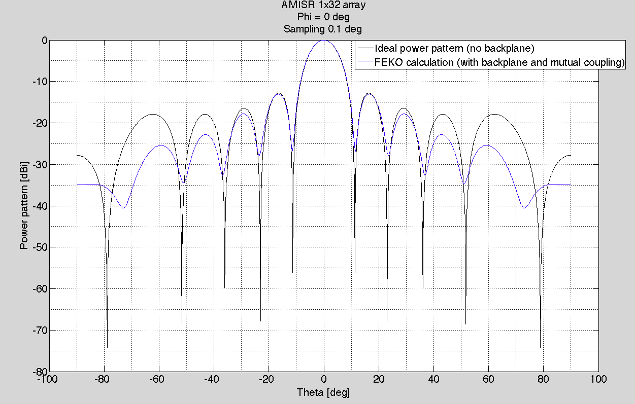

Fig. . AMISR 1x32 normalized radiation intensity, Φ = 0°.

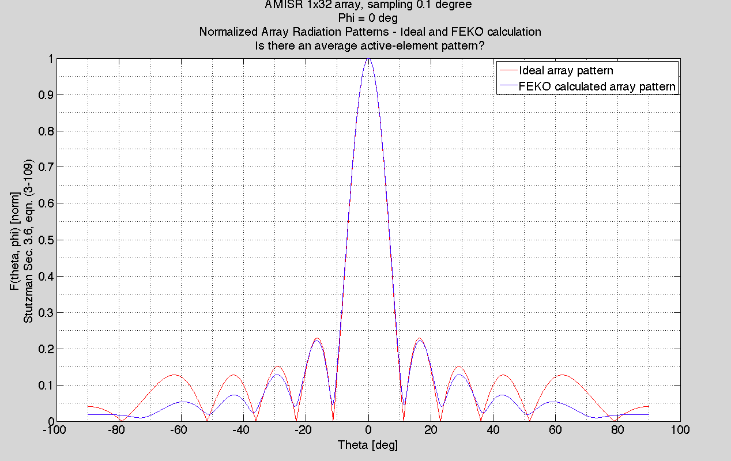

Fig. . AMISR 1x32 normalized radiation pattern, Φ = 0°.

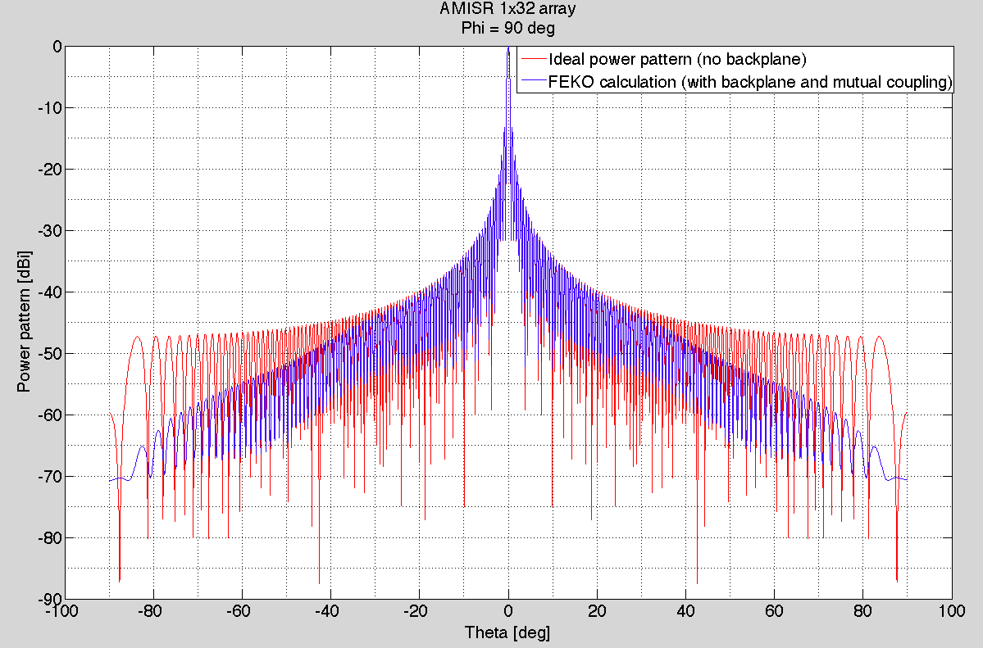

Fig. . AMISR 1x32 normalized radiation intensity, Φ = 90°.

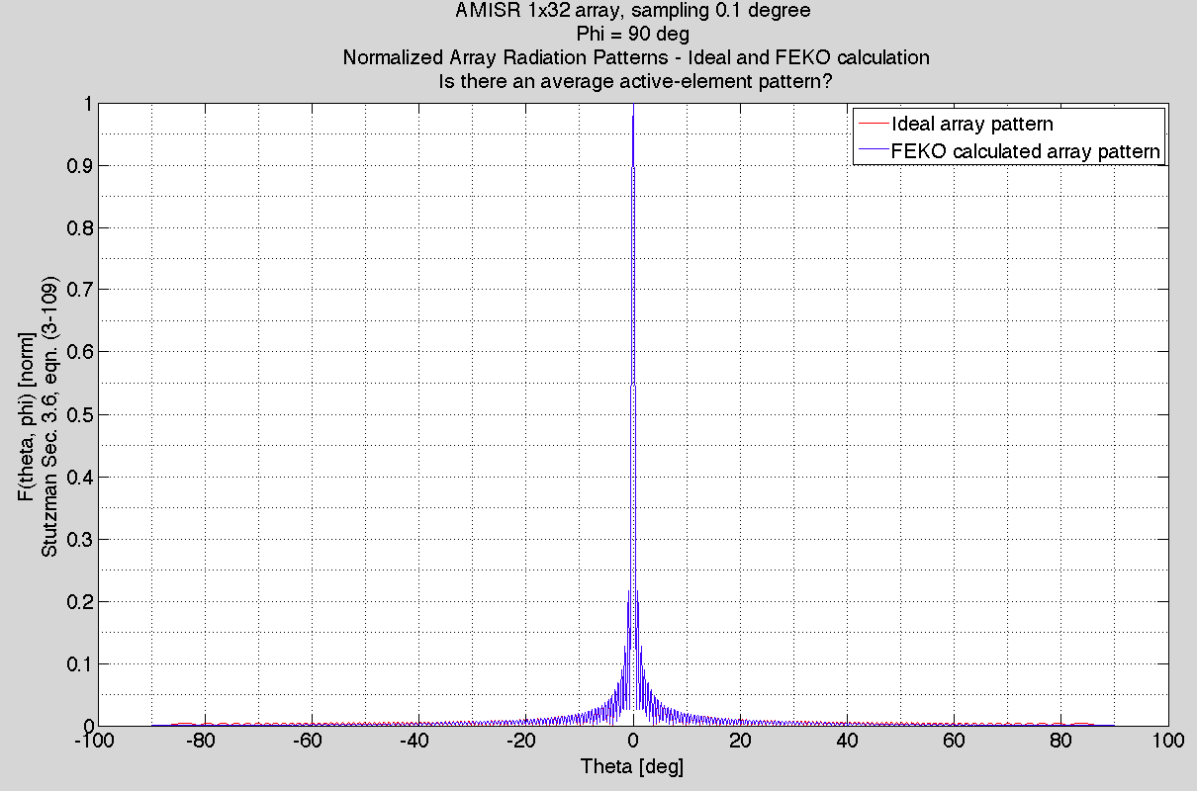

Fig. . AMISR 1x32 normalized radiation pattern, Φ = 90°.

The numerical solution (with mutual coupling) continues to fall, however, as elevation comes down off boresight, differing in some instances by more than 20 dBi from the idealized pattern. For |θ| ≥ 20° this amounts to a θ dependent reduction in relative amplitude for the antenna power pattern, while preserving the relative pattern shape (for θ < 80°).

Figures 8 and 10 show the corresponding normalized radiation patterns (ideal and by MLFMM) for Φ=0, 90°. As suggested by both the gain and pattern plots, the edge effects diminish with center lobe beamwidth. Given the high center-lobe gain, the coupling effects may be insignificant on boresight, or even desirable insofar as they reduce off-center detection. In the Φ = 0° orientation, for example, the calculated edge effect (or, more precisely, the actual radiation intensity pattern) suppresses the third and fourth sidelobe levels at |θ| = 40 or 60°. A θ-dependent average active-element pattern might be extracted from the ratio of normalized antenna radiation patterns for a range of Φ, *see* Appendix, Section II.B, but in general the difference attributable to edge effects at low elevation for the desired low beamwidth Φ=90° scan is marginal.

Similar results can be seen in the Appendix for the 2x4 and 8x16 configurations.

# Conclusions

Mutual coupling appears to have marginal impact on far field patterns for boresight operation in the three configurations investigated at Φ = 0 or 90°. The primary effect is a conceptually beneficial reduction in gain and antenna pattern off beam center, at low elevations. The edge effects appear at elevation greater than 20° from boresight. This suggests that mutual effects may be more significant for beam steering at more than 20° off center, and may warrant further study by numerical techniques set forth in this report.

# Future Simulations

The far field simulations provide richer results than explored in this summary report. For example, the results include data on the far field polarization that has not been explored. That information could be investigated further, in comparison with the idealized array as needed to isolate mutual coupling effects.

Future simulations for AMISR array configurations could examine mutual coupling affects on antenna patterns for beam steering near the grating lobe limits. Given an antenna array configuration, the relevant phase delays could be manually added between dipole elements. Because each cross dipole consists of two ports, this manual approach would entail assigning phase delays for twice as many sources as cross dipole antenna elements. It may be straightforward to script this phase delay specification. Alternatively, the simulation could specify source phase delays / amplitude variations by loading suitable data files from actual AMISR runs for the steering angles of interest. This will require some greater facility with the FEKO suite, as well as more data files from SRI International, but should be tractable. Depending on the array configurations and number of elements, as well as the hardware used, each steering angle may entail several hours for the associated far field radiation pattern calculations. FEKO scripting capability, however, probably allows for largely automating the problem setup.

Appendix

# AMISR 2x4 Array

## Far field radiation intensity (total gain)

|  |  |  |
| --- | --- | --- |
| Table 1  AMISR 2x4 Array Gain | | |
|  | Φ = 0° | Φ = 90° |
|  |  |  |  |
| Peak gain [dBi] | 31.7 | 31.7 |
| 3dB BW [°] | 4.9 | 4.3 |
| Null-null BW [°] | 12 | 10 |
| SLL [dBi] | 13.2 | 13.3 |
| Elements | 256  7x8 | |
| Dimensions [m2] |

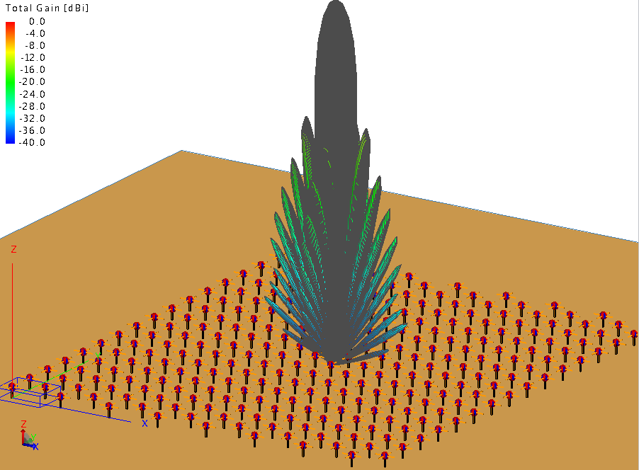

Fig. . AMISR 2x4 array normalized far field total gain (dBi).

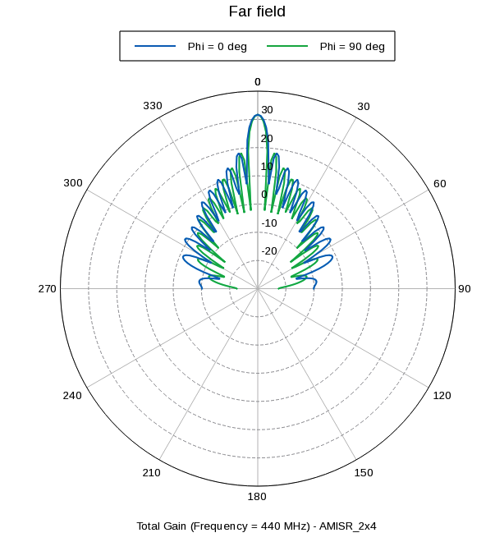

Fig. . AMISR 2x4 array far field total gain (dBi) for Φ = 0, 90° from x axis.

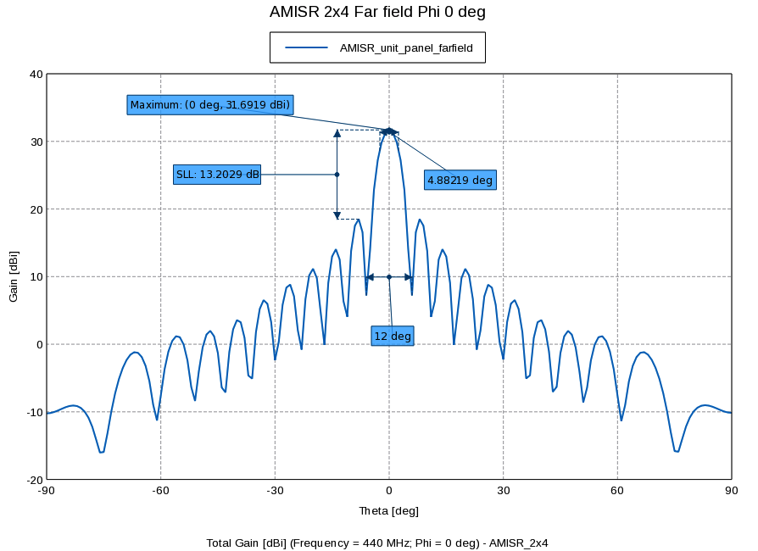

Fig. . AMISR 2x4 array far field total gain (dBi) for Φ = 0° from x axis.

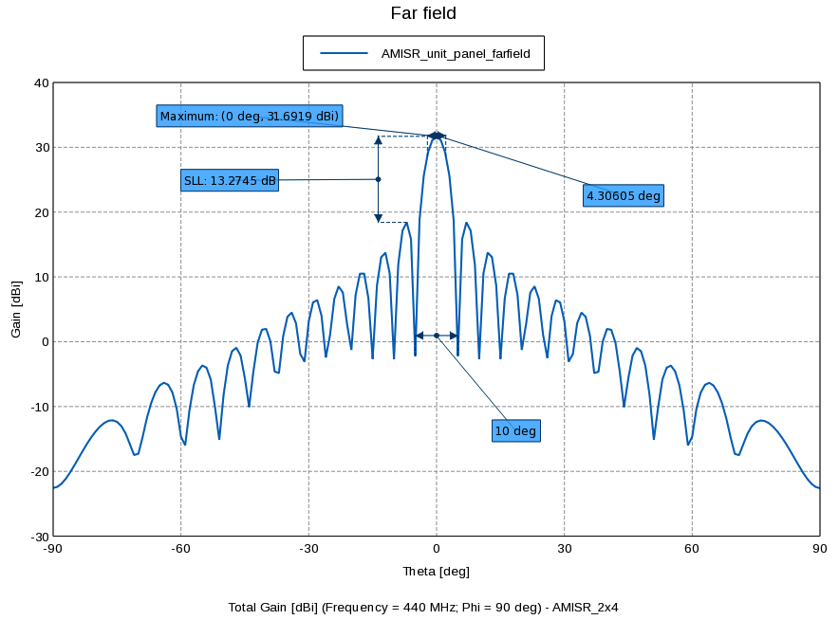

Fig. . AMISR 2x4 array far field total gain (dBi) for Φ = 90° from x axis.

## MLFMM Solution Compared to Ideal Array Pattern

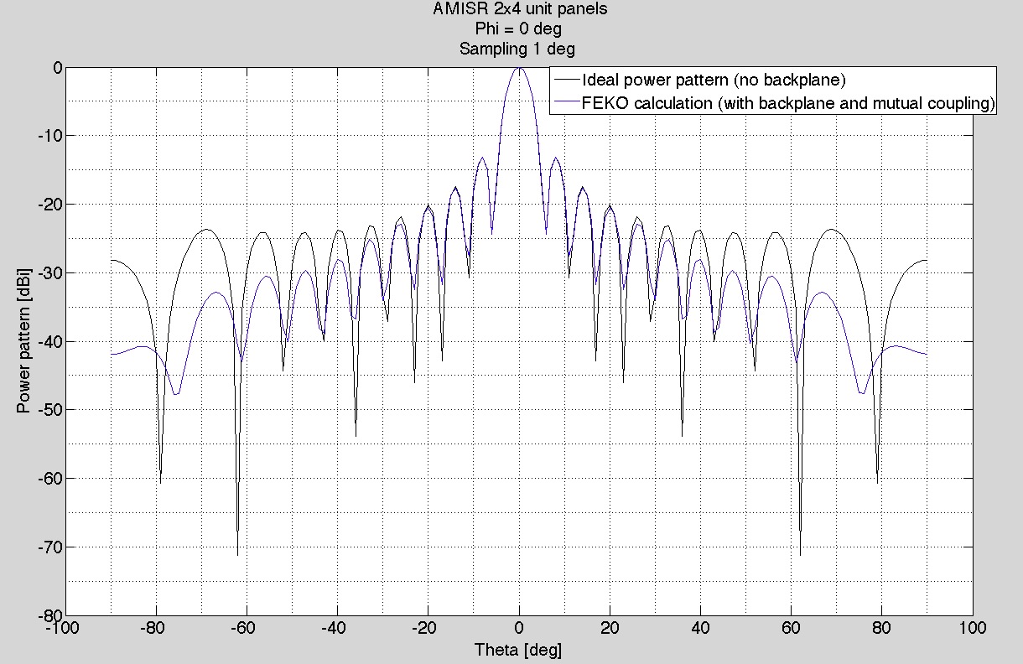

(a)

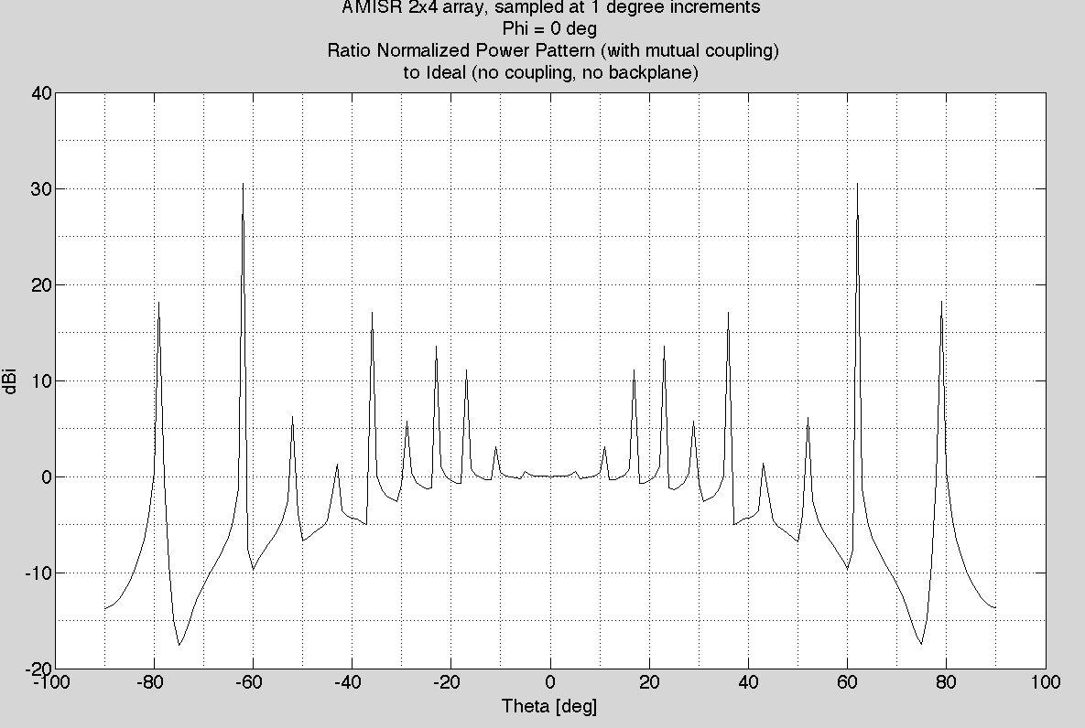

(b)

Fig. . AMISR 2x4 (a) normalized radiation intensity; (b) ratio FEKO solution to ideal array (no backplane), for Φ = 0°.

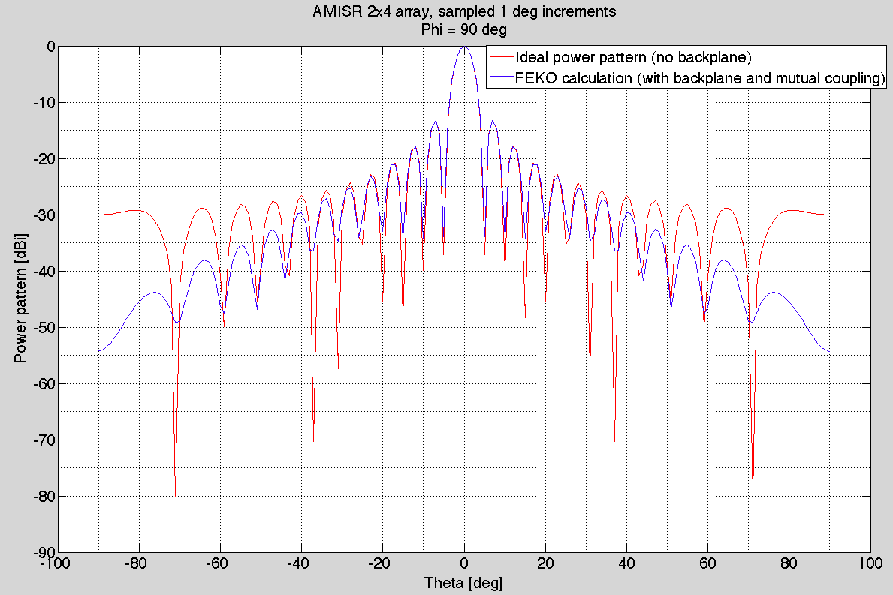

(a)

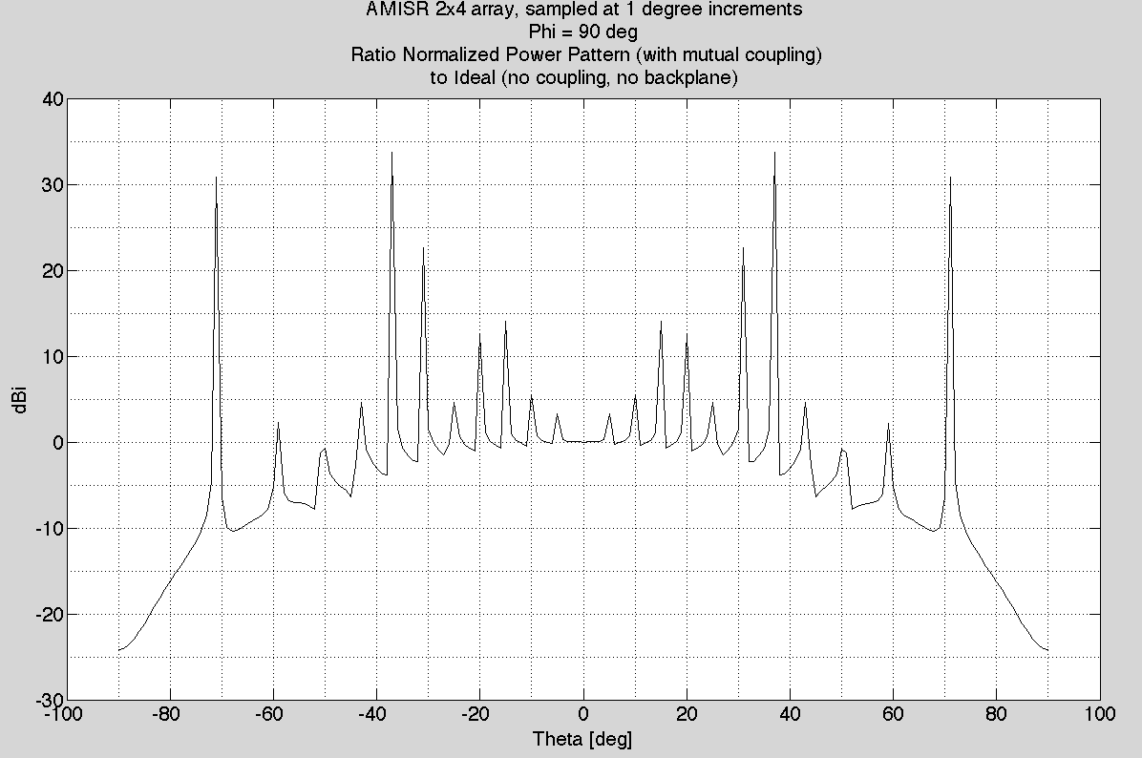

(b)

Fig. . AMISR 2x4 (a) normalized radiation intensity; (b) ratio FEKO solution to ideal array (no backplane), for Φ = 90°.

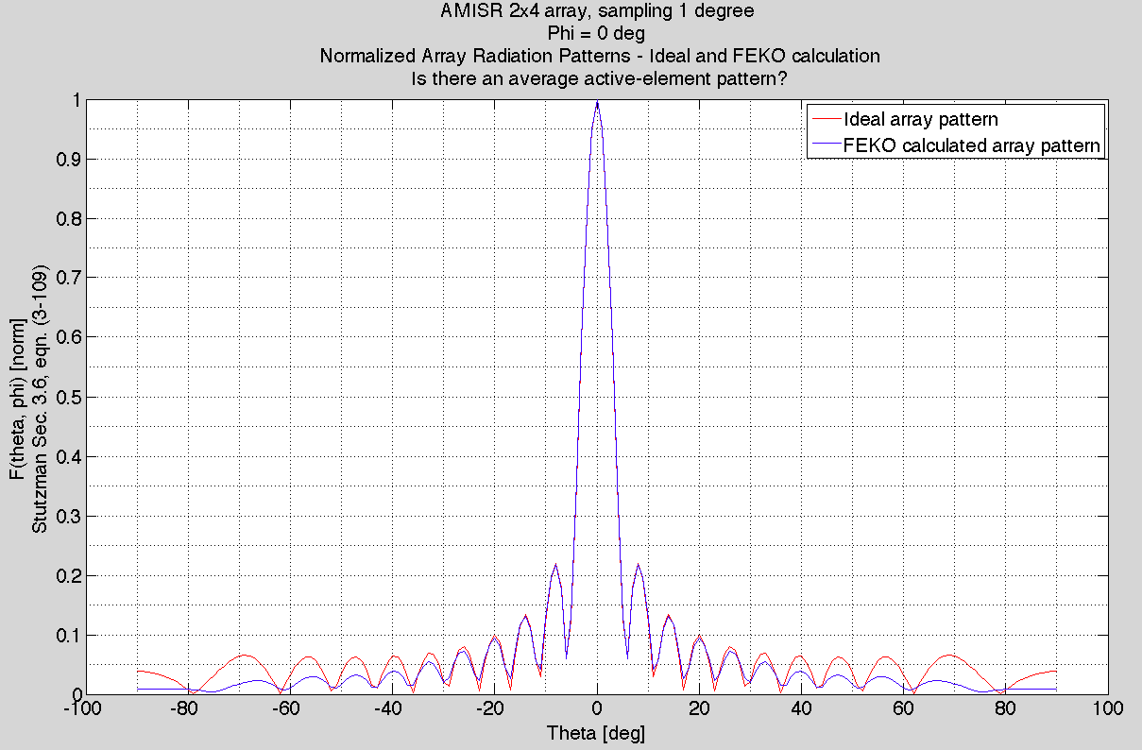

Fig. . AMISR 2x4 normalized array radiation pattern for Φ = 0°.

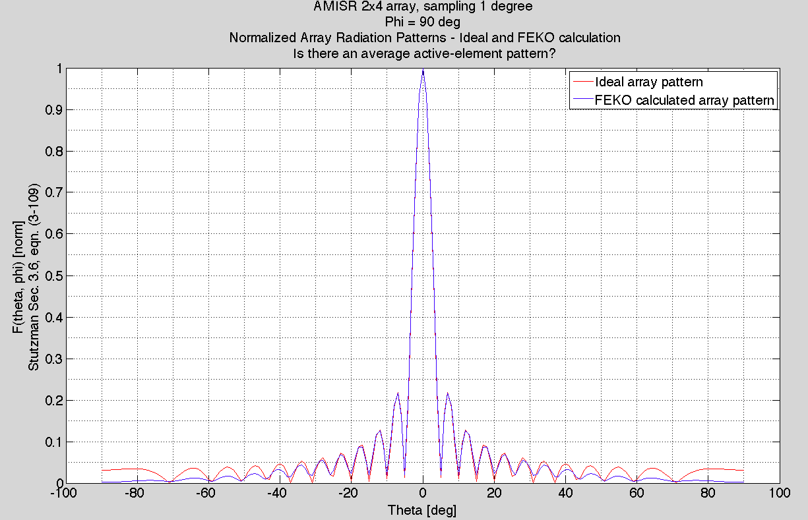

Fig. . AMISR 2x4 normalized array radiation pattern for Φ = 90°.

# AMISR 1x32 Array

## Far field radiation intensity (total gain)

|  |  |  |
| --- | --- | --- |
| Table 2  AMISR 1x32 Array Gain | | |
|  | Φ = 0° | Φ = 90° |
|  |  |  |  |
| Peak gain [dBi] | 37.7 | 37.7 |
| 3dB BW [°] | 10.1 | 0.54 |
| Null-null BW [°] | 23 | 1.2 |
| SLL [dBi] | 13.1 | 13.3 |
| Elements | 1,024  3.5 x 63 | |
| Dimensions [m2] |

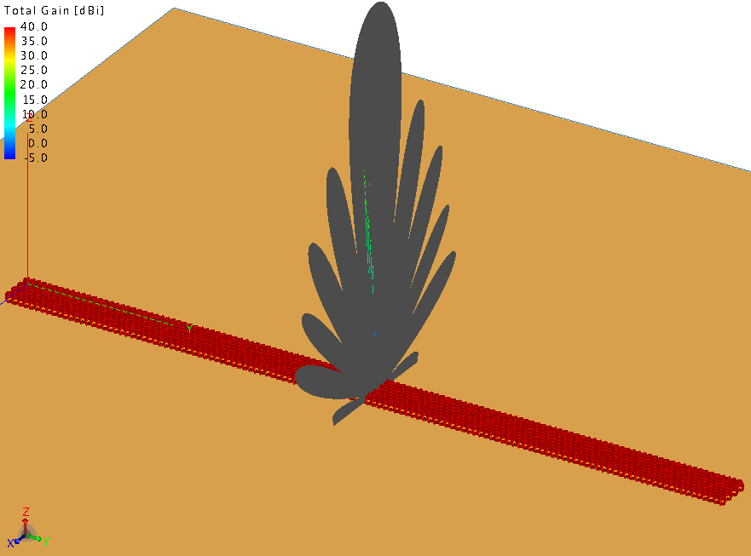

Fig. . AMISR 1x32 array normalized far field total gain (dBi).

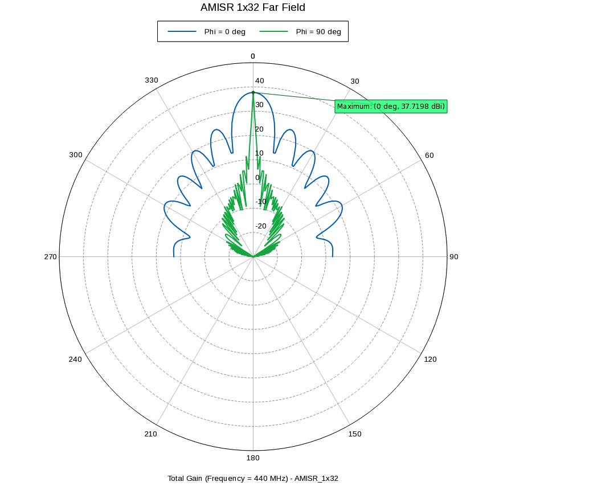

Fig. . AMISR 1x32 array far field total gain (dBi) for Φ = 0, 90° from x axis.

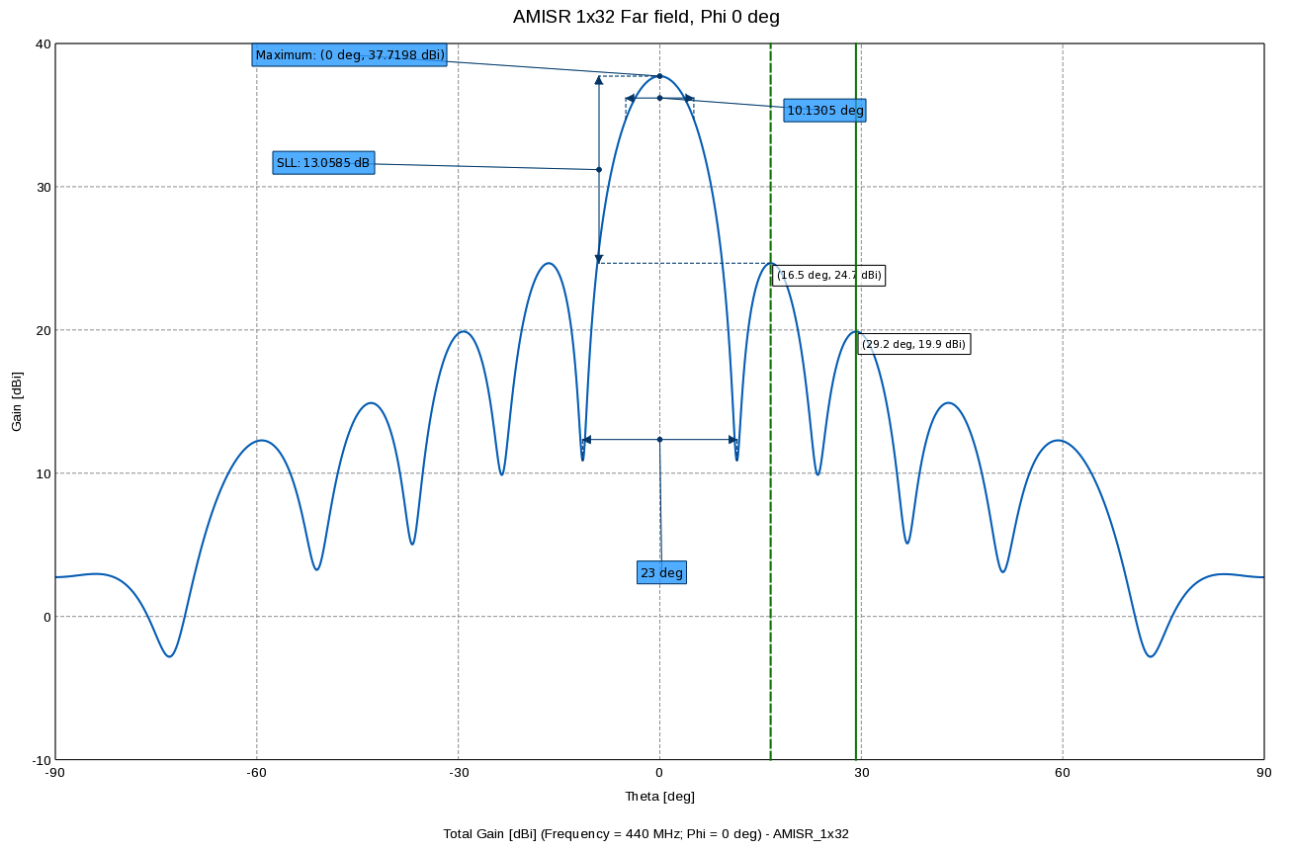

Fig. . AMISR 1x32 array far field total gain (dBi) for Φ = 0° from x axis.

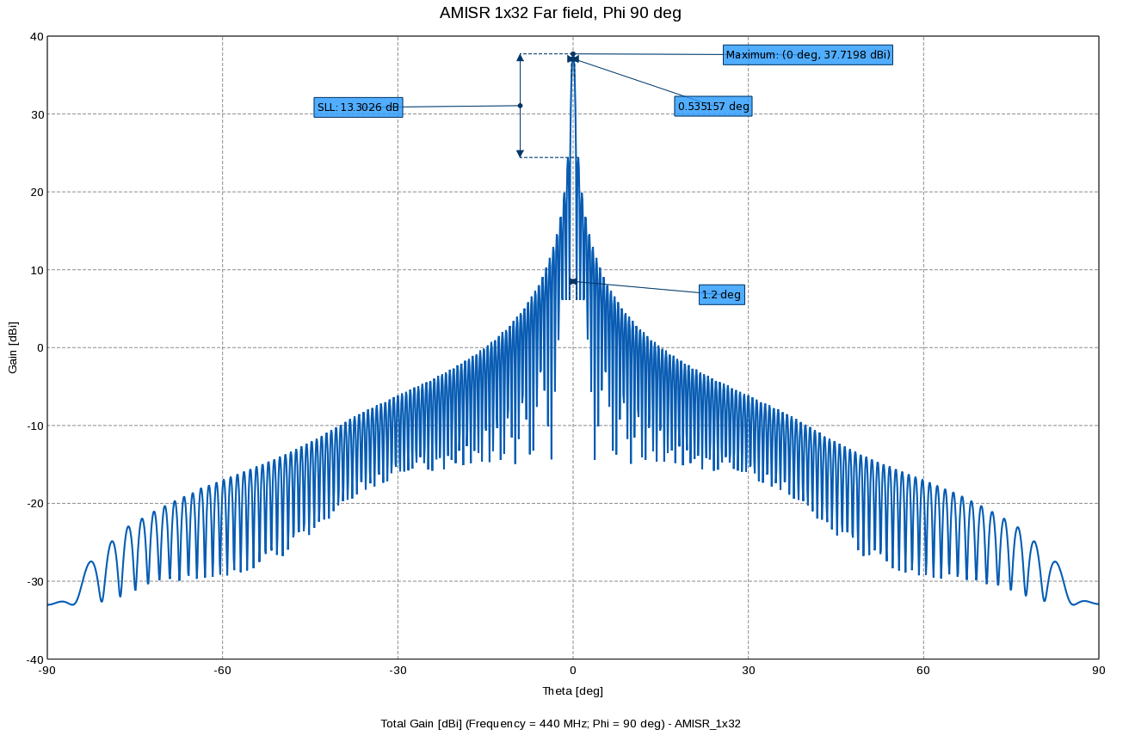

Fig. . AMISR 1x32 array far field total gain (dBi) for Φ = 90° from x axis.

## MLFMM Solution Compared to Ideal Array Pattern



(a)

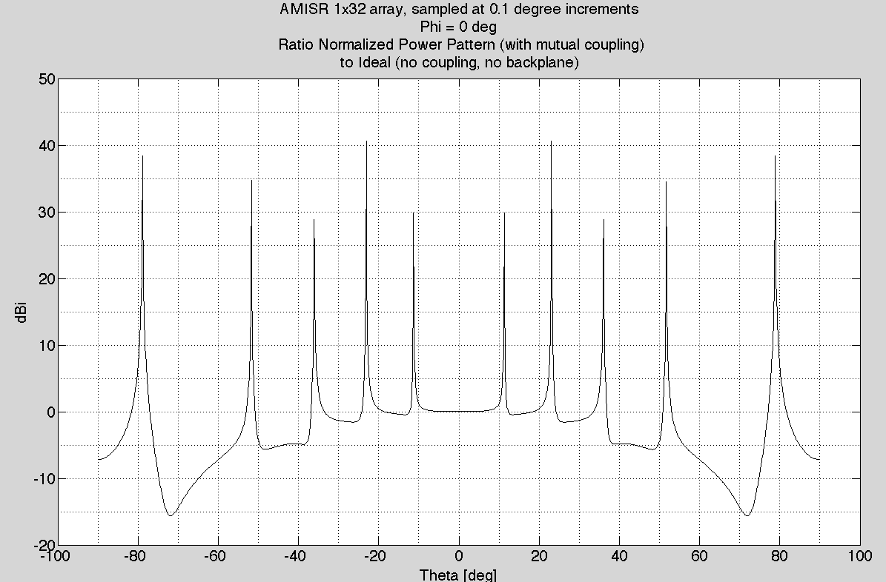

(b)

Fig. . AMISR 1x32 (a) normalized radiation intensity; (b) ratio FEKO solution to ideal array (no backplane), for Φ = 0°.



(a)

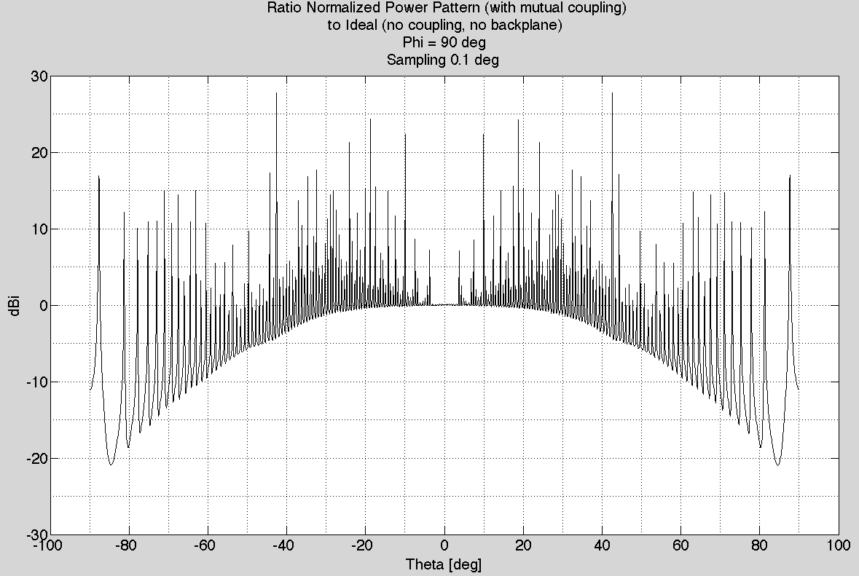

(b)

Fig. . AMISR 1x32 (a) normalized radiation intensity; (b) ratio FEKO solution to ideal array (no backplane), for Φ = 90°.



Fig. . AMISR 1x32 normalized array radiation pattern for Φ = 0°.



Fig. . AMISR 1x32 normalized array radiation pattern for Φ = 90°.

# AMISR 8x16 Array

## Far field radiation intensity (total gain)

|  |  |  |
| --- | --- | --- |
| Table 3  AMISR 8x16 Array Gain | | |
|  | Φ = 0° | Φ = 90° |
|  |  |  |  |
| Peak gain [dBi] | 43.8 | 43.8 |
| 3dB BW [°] | 1.2 | 1.1 |
| Null-null BW [°] | 2.8 | 2.4 |
| SLL [dBi] | 13.3 | 13.3 |
| Elements | 4,096  28 x 32 | |
| Dimensions [m2] |

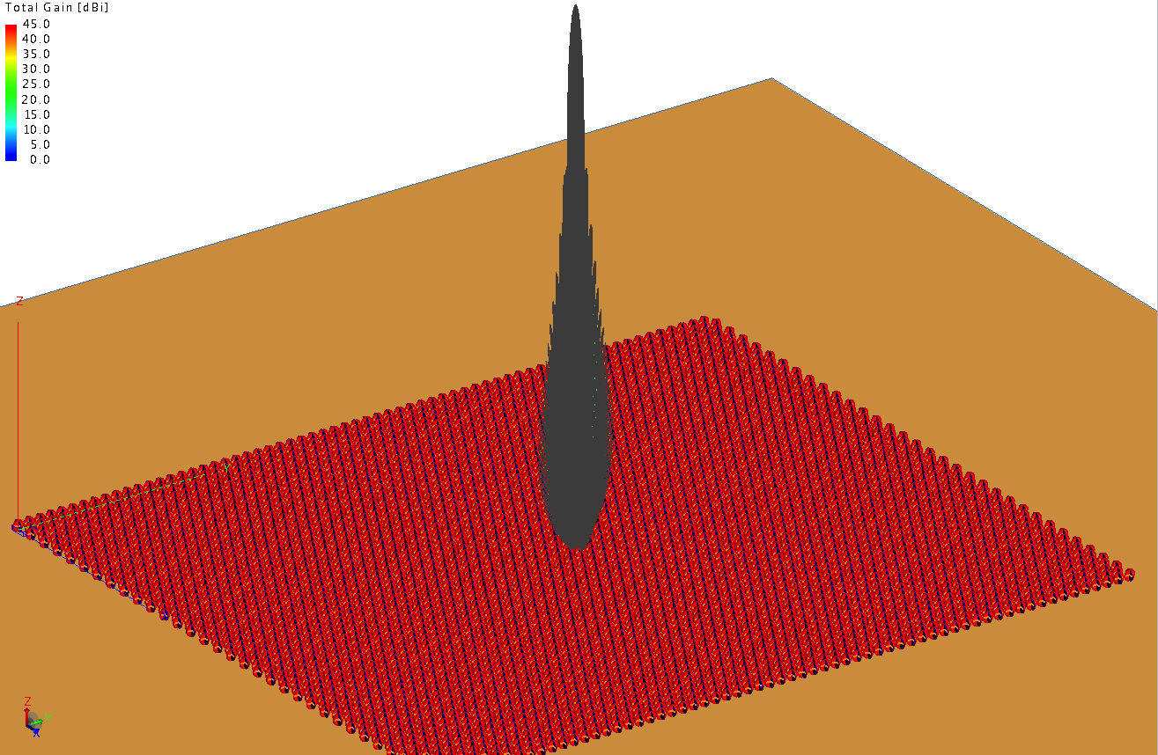

Fig. . AMISR 8x6 array normalized far field total gain (dBi).

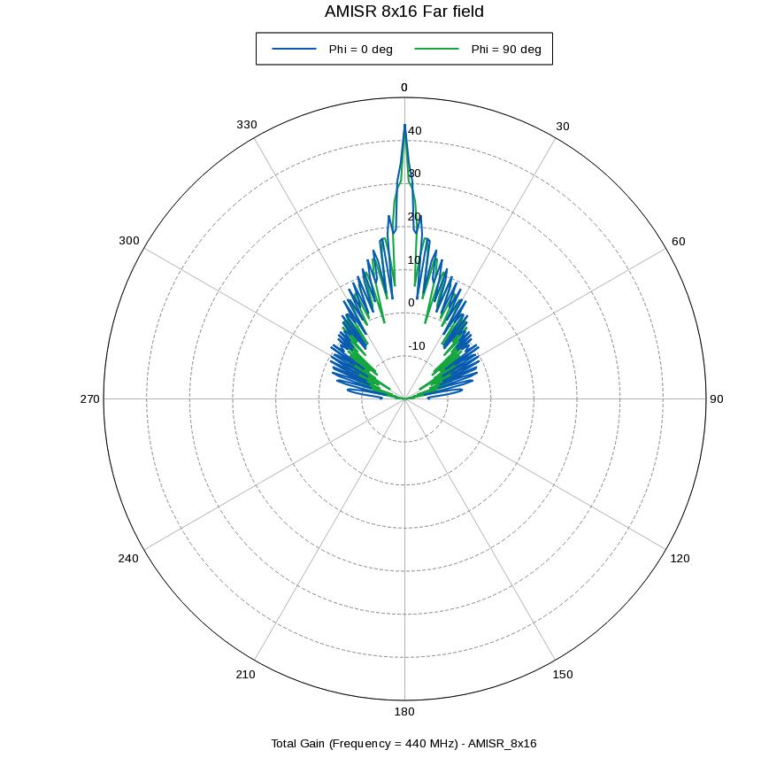

Fig. . AMISR 8x16 array far field total gain (dBi) for Φ = 0, 90° from x axis.

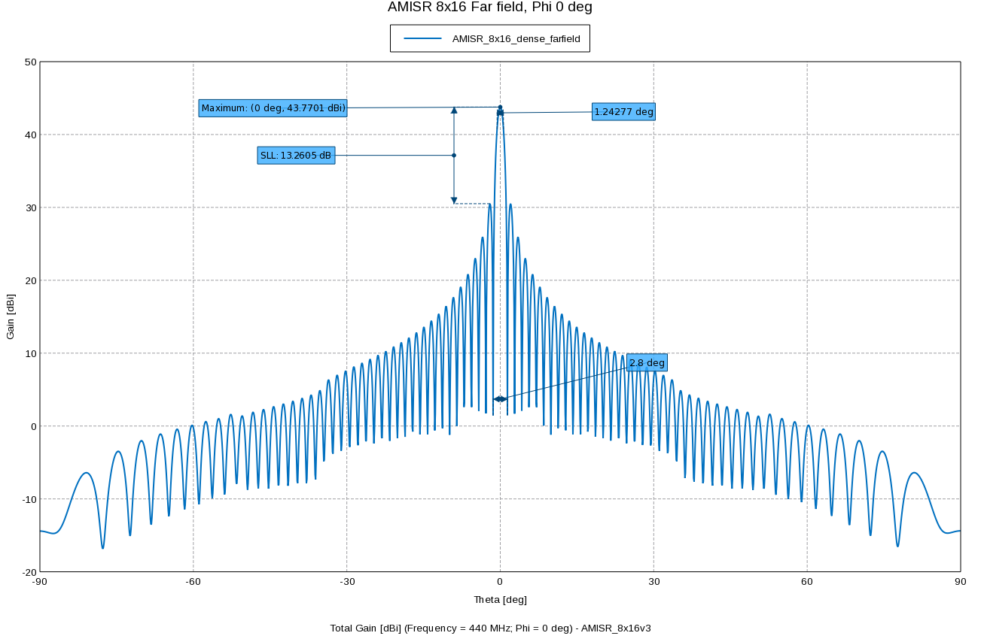

Fig. . AMISR 8x16 array far field total gain (dBi) for Φ = 0° from x axis.

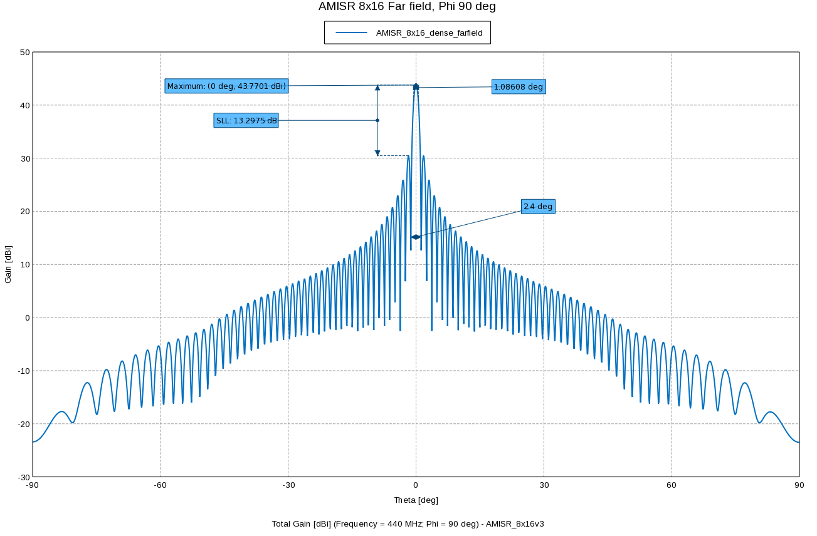

Fig. . AMISR 8x16 array far field total gain (dBi) for Φ = 90° from x axis.

## MLFMM Solution Compared to Ideal Array Pattern

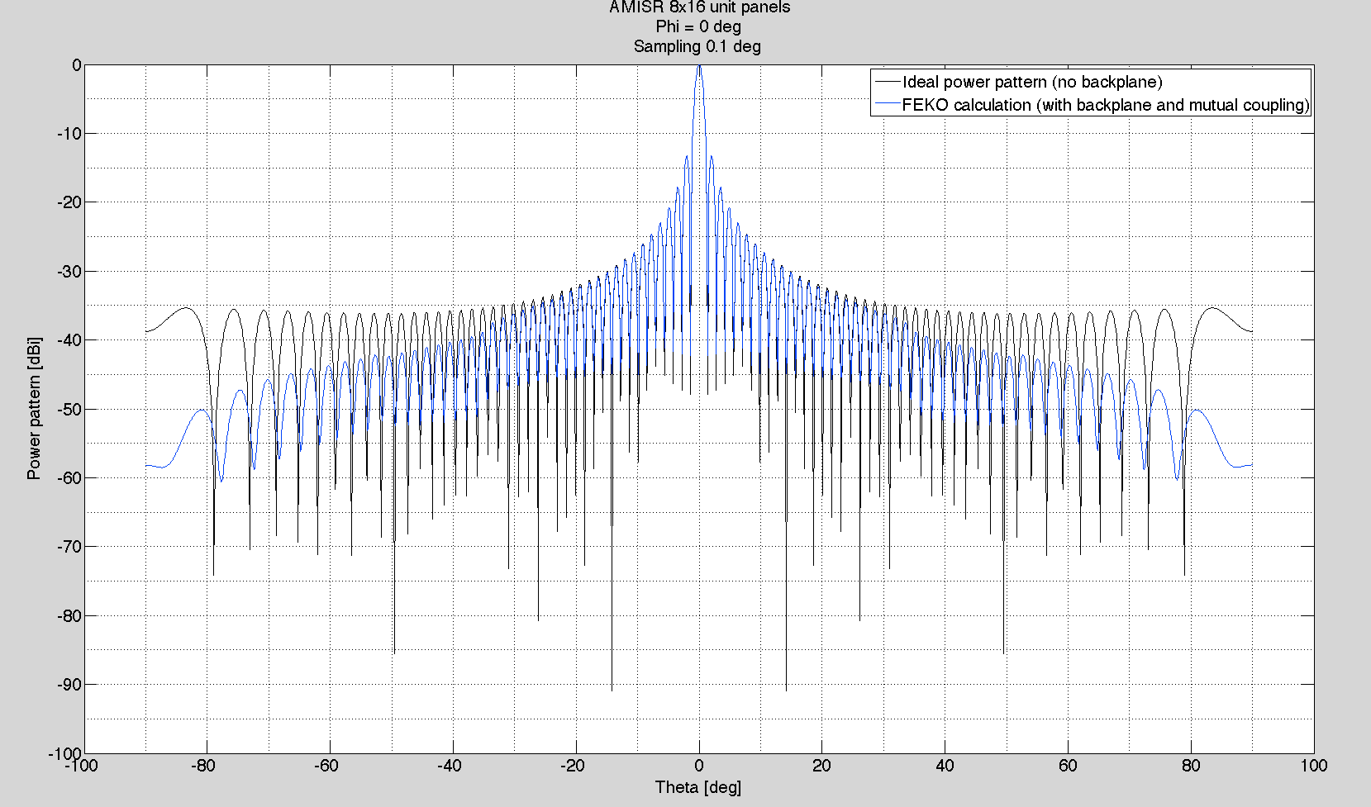

(a)

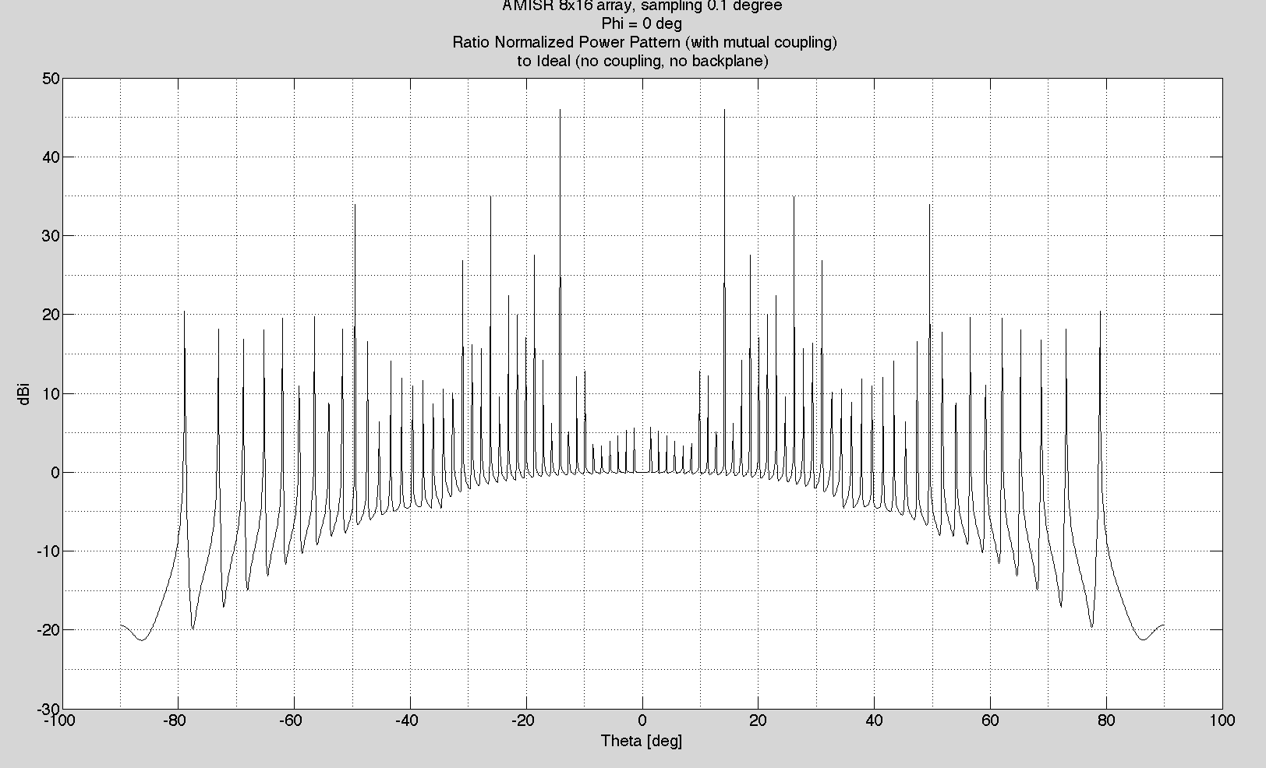

(b)

Fig. . AMISR 8x16 (a) normalized radiation intensity; (b) ratio FEKO solution to ideal array (no backplane), for Φ = 0°.

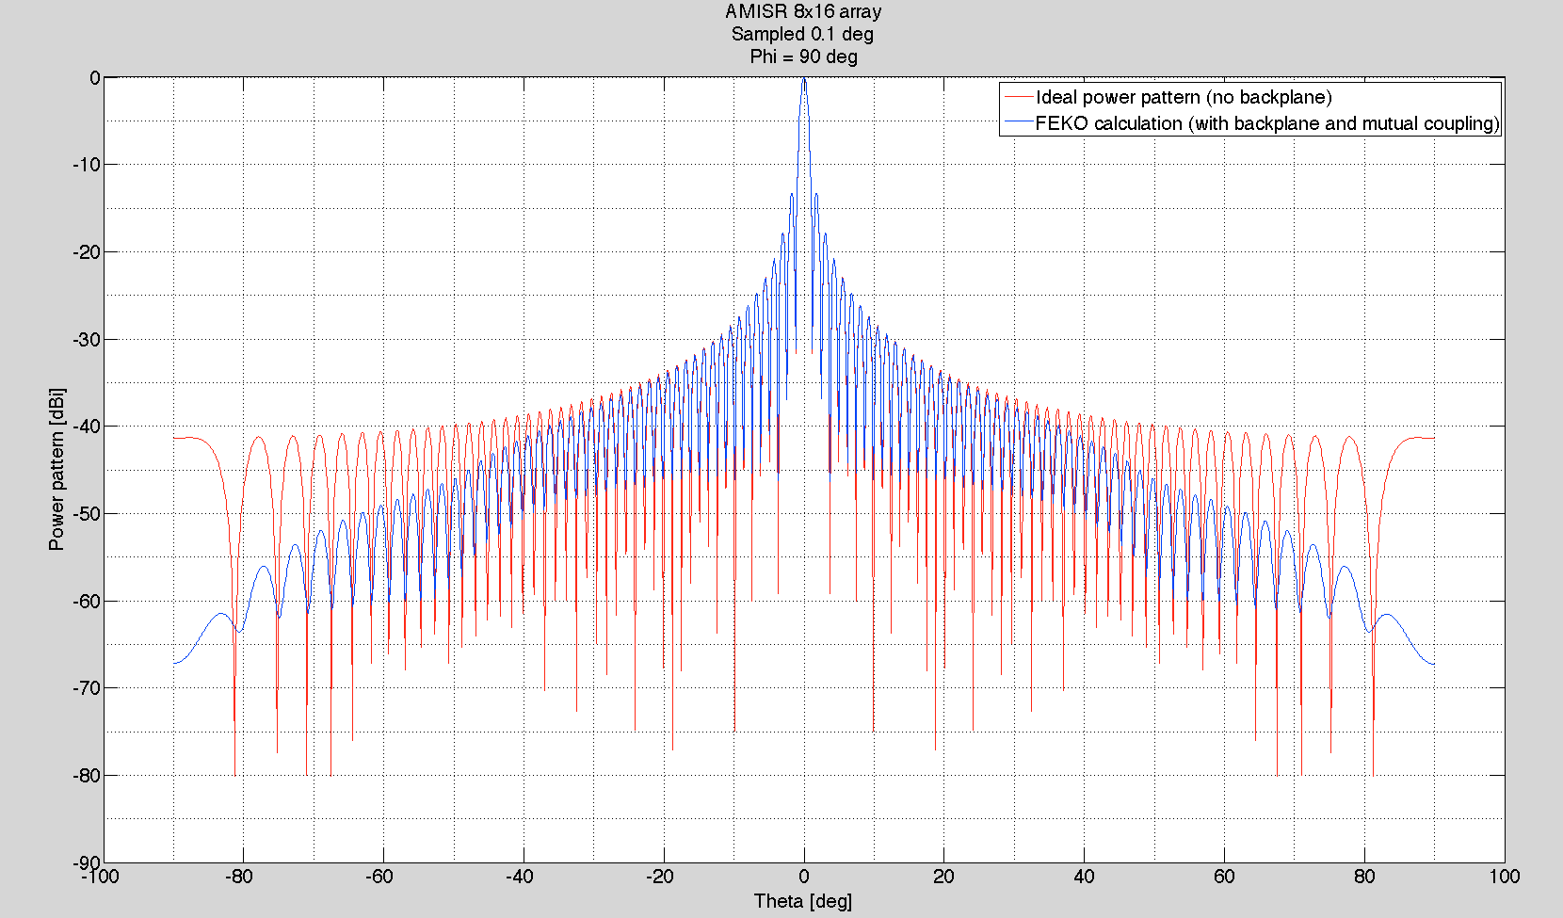

(a)

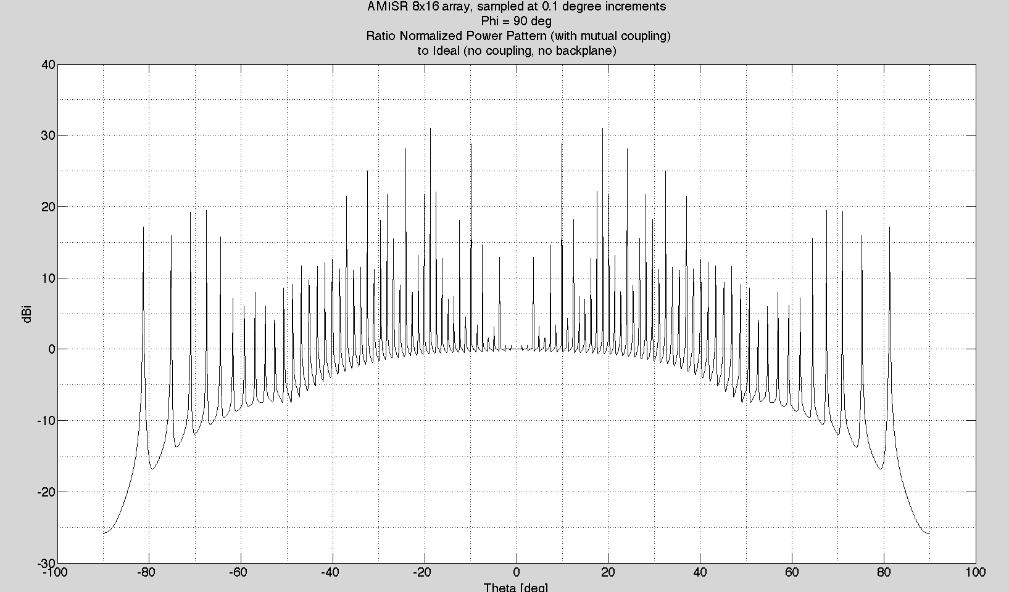

(b)

Fig. . AMISR 8x16 (a) normalized radiation intensity; (b) ratio FEKO solution to ideal array (no backplane), for Φ = 90°.

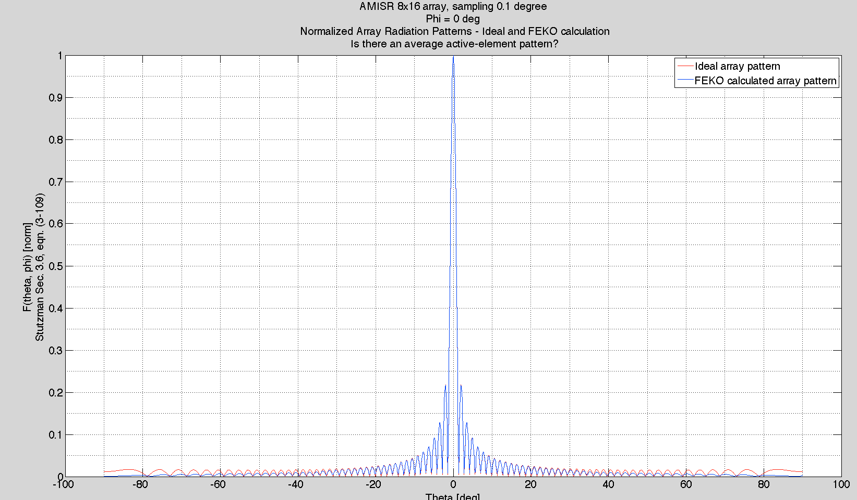

Fig. . AMISR 8x16 normalized array radiation pattern for Φ = 0°.

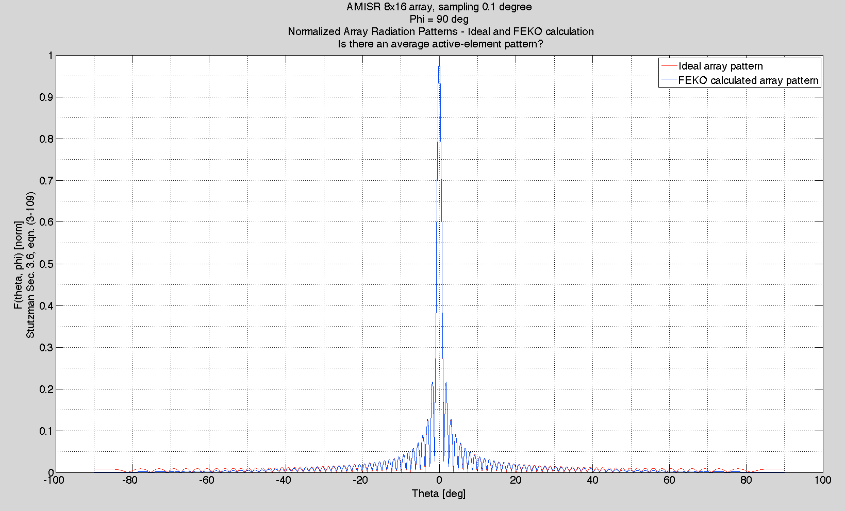

Fig. . AMISR 1x32 normalized array radiation pattern for Φ = 90°

# Matlab Code

clc

clear

close all

% Antenna patterns AMISR arrays EC707 project

% December 9, 2013

%% Load data

%% 1.1. AMISR 2x4

load amisr_2x4_phi0.mat;

load amisr_2x4_phi90.mat;

%% 1.2 AMISR 1x32

%% Sampled at 0.1 deg

% Array pattern in dBV

load amisr_E_1x32_phi0_dense.mat;

load amisr_E_1x32_phi90_dense.mat;

% Array pattern in dBi

load amisr_1x32_phi0_dense.mat;

load amisr_1x32_phi90_dense.mat;

%% 1.3. AMISR_8x16

% total gain dBi

load amisr_8x16_phi0_dense.mat;

load amisr_8x16_phi90_dense.mat;

%% ANALYSIS

% Constants

c0=3e8;

f0=440e6;

lam0=c0/f0;

k0=2*pi/lam0;

dx=0.4343; % [m]

dy=0.4958; % [m]

% Case I: amisr 2x4 array

% I.1. 1 deg sampling

%NN=2^13;

NN=180; % default data samples (1 deg increments)

%NN=180*10; % dense data samples (0.10 deg increments)

m=2 ;

mtot=m*8;

n=4;

ntot=n*4;

thetadeg=-90:(180/NN):90;

theta=thetadeg.*pi/180;

phi1=0;

phi1=phi1*pi/180;

phi2=90;

phi2=phi2*pi/180;

u1=k0*dx*2.*sin(theta)*cos(phi1);

v1=k0*dy.*sin(theta)*sin(phi1);

u2=k0*dx*2.*sin(theta)*cos(phi2);

v2=k0*dy.*sin(theta)*sin(phi2);

x1=0;

x2=0;

for mm=1:mtot/2

for nn=1:ntot

ea_m1= exp(i*(nn-1 -ntot/2).*v1) .* exp(i*(mm-1 - mtot/4).*u1)+...

exp(i*(nn-1-ntot/2).*v1 + i*k0.*sin(theta)*sin(phi1)*dy/2) .* exp(i*(mm-1-mtot/4).*u1+ i*k0*dx.*sin(theta)*cos(phi1)) ;

x1=x1+ea_m1;

ea_m2=exp(i*(nn-1-ntot/2).*v2) .* exp(i*(mm-1-mtot/4).*u2)+...

exp(i*(nn-1 - ntot/2).*v2 + i*k0.*sin(theta)*sin(phi2)*dy/2) .* exp(i*(mm-1 - mtot/4).*u2+ i*k0*dx.*sin(theta)*cos(phi2)) ;

x2=x2+ea_m2;

end; % end for nn

end; % end for mm

ea1=[thetadeg; x1];

ea2=[thetadeg; x2];

elementpower1=1+(cos(phi1)).^2;

elementpower2=1+(cos(phi2)).^2;

antpow1=abs(ea1(2,:));

antpow1=elementpower1.*antpow1.^2;

antpow1=antpow1./max(antpow1);

pdb1=10.*log10(antpow1);

peak1=max(pdb1)

antpow2=abs(ea2(2,:));

antpow2=elementpower2.*antpow2.^2;

antpow2=antpow2./max(antpow2);

pdb2=10.*log10(antpow2);

p1=[thetadeg; ea1(2,:); pdb1];

p2=[thetadeg; ea2(2,:); pdb2];

%% PLOT

% 2.2.1 AMISR 2x4, 1 degree sampling

% Phi 0 deg

figure(11)

plot(p1(1,:), p1(3,:), '-k')

grid on

grid minor

set(gca,'Fontsize',20)

xlabel('Theta [deg]')

ylabel('Power pattern [dBi]')

title({'AMISR 2x4 array';'Phi = 0 deg';'Sampling 1 deg'})

[pksphi0,locsphi0] = findpeaks(p1(3,:));

hold on

c1=amisr_2x4_phi0;

c1(:,2)=c1(:,2)-max(c1(:,2));

plot(c1(:,1), c1(:,2), '-b')

legend('Ideal power pattern (no backplane)', 'FEKO calculation (with backplane and mutual coupling)')

c2=c1(:,2)-pdb1';

figure(12)

plot(c1(:,1), c2, '-k')

grid on

grid minor

set(gca, 'FontSize',20)

title({'AMISR 2x4 array, sampling 1 degree', 'Phi = 0 deg',...

'Ratio Normalized Power Pattern (with mutual coupling)', 'to Ideal (no coupling, no backplane)'})

xlabel('Theta [deg]')

ylabel('dBi')

% Smooth ratio at grating lobe peaks

[pks2x4phi0, locs]=findpeaks(pdb1);

[FEKOpks2x4phi0, FEKOlocs]=findpeaks(c1(:,2));

hold on

% Phi 90 deg

figure(13)

plot(p2(1,:), (pdb2'),'-r')

grid on

grid minor

set(gca,'Fontsize',20)

xlabel('Theta [deg]')

ylabel('Power pattern [dBi]')

title({'AMISR 2x4 array, sampling 1 deg';'Phi = 90 deg'})

hold on

[pksphi90,locsphi90] = findpeaks(pdb2);

c90=amisr_2x4_phi90;

c90(:,2)=c90(:,2)-max(c90(:,2));

plot(c90(:,1), c90(:,2), '-b')

legend('Ideal power pattern (no backplane)', 'FEKO calculation (with backplane and mutual coupling)')

[FEKOpksphi90,FEKOlocsphi90] = findpeaks(c1(:,2));

c2=c90(:,2)-pdb2';

figure(14)

plot(c1(:,1), c2, '-k')

grid on

grid minor

set(gca, 'FontSize',20)

title({'AMISR 2x4 array, sampling 1 degree', 'Phi = 90 deg',...

'Ratio Normalized Power Pattern (with mutual coupling)', 'to Ideal (no coupling, no backplane)'})

xlabel('Theta [deg]')

ylabel('dBi')

figure(15)

d1=sqrt(elementpower1).*abs(ea1(2,:));

d1=d1./max(d1);

plot( c1(:,1), d1, '-r');

hold on

grid on

grid minor

c2=amisr_2x4_phi0(:,2);

d2=10.^(0.1*0.5.*c2);

d2=d2./max(d2);

plot( c1(:,1), d2, '-b');

d3=d2./d1';

set(gca, 'FontSize',20)

title({'AMISR 2x4 array, sampling 1 degree', 'Phi = 0 deg',...

'Normalized Array Radiation Patterns - Ideal and FEKO calculation', 'Is there an average active-element pattern?'})

xlabel('Theta [deg]')

ylabel({'F(theta, phi) [norm]','Stutzman Sec. 3.6, eqn. (3-109)'})

legend('Ideal array pattern', 'FEKO calculated array pattern')

figure(16)

d1=sqrt(elementpower2).*abs(ea2(2,:));

d1=d1./max(d1);

plot( c1(:,1), d1, '-r');

hold on

grid on

grid minor

c2=amisr_2x4_phi90(:,2);

d2=10.^(0.1*0.5.*c2);

d2=d2./max(d2);

plot( c1(:,1), d2, '-b');

d3=d2./d1';

set(gca, 'FontSize',20)

title({'AMISR 2x4 array, sampling 1 degree', 'Phi = 90 deg',...

'Normalized Array Radiation Patterns - Ideal and FEKO calculation', 'Is there an average active-element pattern?'})

xlabel('Theta [deg]')

ylabel({'F(theta, phi) [norm]','Stutzman Sec. 3.6, eqn. (3-109)'})

legend('Ideal array pattern', 'FEKO calculated array pattern')

%% Case II: AMISR 1x32

%NN=2^13;

%NN=180; % default data samples (1 deg increments)

NN=180*10; % dense data samples (0.10 deg increments)

m=1 ;

mtot=m*8;

n=32;

ntot=n*4;

thetadeg=-90:(180/NN):90;

theta=thetadeg.*pi/180;

phi1=0;

phi1=phi1*pi/180;

phi2=90;

phi2=phi2*pi/180;

u1=k0*dx*2.*sin(theta)*cos(phi1);

v1=k0*dy.*sin(theta)*sin(phi1);

u2=k0*dx*2.*sin(theta)*cos(phi2);

v2=k0*dy.*sin(theta)*sin(phi2);

x1=0;

x2=0;

for mm=1:mtot/2

for nn=1:ntot

ea_m1= exp(i*(nn-1 -ntot/2).*v1) .* exp(i*(mm-1 - mtot/4).*u1)+...

exp(i*(nn-1-ntot/2).*v1 + i*k0.*sin(theta)*sin(phi1)*dy/2) .* exp(i*(mm-1-mtot/4).*u1+ i*k0*dx.*sin(theta)*cos(phi1)) ;

x1=x1+ea_m1;

ea_m2=exp(i*(nn-1-ntot/2).*v2) .* exp(i*(mm-1-mtot/4).*u2)+...

exp(i*(nn-1 - ntot/2).*v2 + i*k0.*sin(theta)*sin(phi2)*dy/2) .* exp(i*(mm-1 - mtot/4).*u2+ i*k0*dx.*sin(theta)*cos(phi2)) ;

x2=x2+ea_m2;

end; % end for nn

end; % end for mm

ea1=[thetadeg; x1];

ea2=[thetadeg; x2];

elementpower1=1+(cos(phi1)).^2;

elementpower2=1+(cos(phi2)).^2;

antpow1=abs(ea1(2,:));

antpow1=elementpower1.*antpow1.^2;

antpow1=antpow1./max(antpow1);

pdb1=10.*log10(antpow1);

peak1=max(pdb1);

antpow2=abs(ea2(2,:));

ap90=ea2(2,:).*sqrt(elementpower2);

ap90db=10.*log10(ap90);

antpow2=elementpower2.*antpow2.^2;

antpow2=antpow2./max(antpow2);

pdb2=10.*log10(antpow2);

p1=[thetadeg; ea1(2,:); pdb1];

p2=[thetadeg; ea2(2,:); pdb2];

%% PLOT

% Phi 0 deg

figure(2221)

plot(p1(1,:), p1(3,:), '-k')

grid on

grid minor

set(gca,'Fontsize',20)

xlabel('Theta [deg]')

ylabel('Power pattern [dBi]')

title({'AMISR 1x32 array';'Phi = 0 deg';'Sampling 0.1 deg'})

[pksphi0,locsphi0] = findpeaks(p1(3,:));

hold on

c1=amisr_1x32_phi0_dense;

c1(:,2)=c1(:,2)-max(c1(:,2));

plot(c1(:,1), c1(:,2), '-b')

legend('Ideal power pattern (no backplane)', 'FEKO calculation (with backplane and mutual coupling)')

c2=c1(:,2)-pdb1';

figure(2222)

plot(c1(:,1), c2, '-k')

grid on

grid minor

set(gca, 'FontSize',20)

title({'AMISR 1x32 array, sampling 0.1 degree', 'Phi = 0 deg','Ratio Normalized Power Pattern (with mutual coupling)', 'to Ideal (no coupling, no backplane)'})

xlabel('Theta [deg]')

ylabel('dBi')

% Smooth ratio at grating lobe peaks

[pks1x32phi0, locs]=findpeaks(pdb1);

[FEKOpks1x32phi0, FEKOlocs]=findpeaks(c1(:,2));

hold on

% Phi 90 deg

figure(2223)

plot(p2(1,:), (pdb2'),'-r')

grid on

grid minor

set(gca,'Fontsize',20)

xlabel('Theta [deg]')

ylabel('Power pattern [dBi]')

title({'AMISR 1x32 array';'Phi = 90 deg'})

hold on

[pksphi90,locsphi90] = findpeaks(pdb2);

c90_1=amisr_1x32_phi90_dense(:,1);

c90_2=amisr_1x32_phi90_dense(:,2);

%c90=amisr_1x32_phi90_dense;

c90_2=c90_2-max(c90_2);

plot(c90_1, c90_2, '-b')

legend('Ideal power pattern (no backplane)', 'FEKO calculation (with backplane and mutual coupling)')

[FEKOpksphi90,FEKOlocsphi90] = findpeaks(c1(:,2));

c2=c90_2-pdb2';

figure(2224)

plot(c1(:,1), c2, '-k')

grid on

grid minor

set(gca, 'FontSize',20)

title({'Ratio Normalized Power Pattern (with mutual coupling)', 'to Ideal (no coupling, no backplane)','Phi = 90 deg','Sampling 0.1 deg'})

xlabel('Theta [deg]')

ylabel('dBi')

figure(22215)

d1=sqrt(elementpower1).*abs(ea1(2,:));

d1=d1./max(d1);

plot( c1(:,1), d1, '-r');

hold on

grid on

grid minor

c2=amisr_1x32_phi0_dense(:,2);

d2=10.^(0.1*0.5.*c2);

d2=d2./max(d2);

plot( c1(:,1), d2, '-b');

d3=d2./d1';

set(gca, 'FontSize',20)

title({'AMISR 1x32 array, sampling 0.1 degree', 'Phi = 0 deg',...

'Normalized Array Radiation Patterns - Ideal and FEKO calculation', 'Is there an average active-element pattern?'})

xlabel('Theta [deg]')

ylabel({'F(theta, phi) [norm]','Stutzman Sec. 3.6, eqn. (3-109)'})

legend('Ideal array pattern', 'FEKO calculated array pattern')

figure(22216)

d1=sqrt(elementpower2).*abs(ea2(2,:));

d1=d1./max(d1);

plot( c1(:,1), d1, '-r');

hold on

grid on

grid minor

c2=amisr_1x32_phi90_dense(:,2);

d2=10.^(c2./20);

d2=d2./max(d2);

plot( c1(:,1), d2, '-b');

d3=d2./d1';

set(gca, 'FontSize',20)

title({'AMISR 1x32 array, sampling 0.1 degree', 'Phi = 90 deg',...

'Normalized Array Radiation Patterns - Ideal and FEKO calculation', 'Is there an average active-element pattern?'})

xlabel('Theta [deg]')

ylabel({'F(theta, phi) [norm]','Stutzman Sec. 3.6, eqn. (3-109)'})

legend('Ideal array pattern', 'FEKO calculated array pattern')

%% Case III: AMISR 8x16

%NN=2^13;

%NN=180; % default data samples (1 deg increments)

NN=180*10; % dense data samples (0.10 deg increments)

m=8 ;

mtot=m*8;

n=16;

ntot=n*4;

thetadeg=-90:(180/NN):90;

theta=thetadeg.*pi/180;

phi1=0;

phi1=phi1*pi/180;

phi2=90;

phi2=phi2*pi/180;

u1=k0*dx*2.*sin(theta)*cos(phi1);

v1=k0*dy.*sin(theta)*sin(phi1);

u2=k0*dx*2.*sin(theta)*cos(phi2);

v2=k0*dy.*sin(theta)*sin(phi2);

x1=0;

x2=0;

for mm=1:mtot/2

for nn=1:ntot

ea_m1= exp(i*(nn-1 -ntot/2).*v1) .* exp(i*(mm-1 - mtot/4).*u1)+...

exp(i*(nn-1-ntot/2).*v1 + i*k0.*sin(theta)*sin(phi1)*dy/2) .* exp(i*(mm-1-mtot/4).*u1+ i*k0*dx.*sin(theta)*cos(phi1)) ;

x1=x1+ea_m1;

ea_m2=exp(i*(nn-1-ntot/2).*v2) .* exp(i*(mm-1-mtot/4).*u2)+...

exp(i*(nn-1 - ntot/2).*v2 + i*k0.*sin(theta)*sin(phi2)*dy/2) .* exp(i*(mm-1 - mtot/4).*u2+ i*k0*dx.*sin(theta)*cos(phi2)) ;

x2=x2+ea_m2;

end; % end for nn

end; % end for mm

ea1=[thetadeg; x1];

ea2=[thetadeg; x2];

elementpower1=1+(cos(phi1)).^2;

elementpower2=1+(cos(phi2)).^2;

antpow1=abs(ea1(2,:));

antpow1=elementpower1.*antpow1.^2;

antpow1=antpow1./max(antpow1);

pdb1=10.*log10(antpow1);

peak1=max(pdb1);

antpow2=abs(ea2(2,:));

antpow2=elementpower2.*antpow2.^2;

antpow2=antpow2./max(antpow2);

pdb2=10.*log10(antpow2);

p1=[thetadeg; ea1(2,:); pdb1];

p2=[thetadeg; ea2(2,:); pdb2];

%% PLOT

% Phi 0 deg

figure(321)

plot(p1(1,:), p1(3,:), '-k')

grid on

grid minor

set(gca,'Fontsize',20)

xlabel('Theta [deg]')

ylabel('Power pattern [dBi]')

title({'AMISR 8x16 unit panels';'Phi = 0 deg';'Sampling 0.1 deg'})

[pksphi0,locsphi0] = findpeaks(p1(3,:));

hold on

c1=amisr_8x16_phi0_dense;

c1(:,2)=c1(:,2)-max(c1(:,2));

plot(c1(:,1), c1(:,2), '-b')

legend('Ideal power pattern (no backplane)', 'FEKO calculation (with backplane and mutual coupling)')

c2=c1(:,2)-pdb1';

figure(322)

plot(c1(:,1), c2, '-k')

grid on

grid minor

set(gca, 'FontSize',20)

title({'AMISR 8x16 array, sampling 0.1 degree', 'Phi = 0 deg',...

'Ratio Normalized Power Pattern (with mutual coupling)', 'to Ideal (no coupling, no backplane)'})

xlabel('Theta [deg]')

ylabel('dBi')

% Smooth ratio at grating lobe peaks

[pks1x32phi0, locs]=findpeaks(pdb1);

[FEKOpks1x32phi0, FEKOlocs]=findpeaks(c1(:,2));

hold on

% Phi 90 deg

figure(323)

plot(p2(1,:), (pdb2'),'-r')

grid on

grid minor

set(gca,'Fontsize',20)

xlabel('Theta [deg]')

ylabel('Power pattern [dBi]')

title({'AMISR 8x16 array';'Sampled 0.1 deg';'Phi = 90 deg'})

hold on

[pksphi90,locsphi90] = findpeaks(pdb2);

c90=amisr_8x16_phi90_dense;

c90(:,2)=c90(:,2)-max(c90(:,2));

plot(c90(:,1), c90(:,2), '-b')

legend('Ideal power pattern (no backplane)', 'FEKO calculation (with backplane and mutual coupling)')

[FEKOpksphi90,FEKOlocsphi90] = findpeaks(c1(:,2));

c2=c90(:,2)-pdb2';

figure(324)

plot(c1(:,1), c2, '-k')

grid on

grid minor

set(gca, 'FontSize',20)

title({'AMISR 8x16 array, sampled at 0.1 degree increments', 'Phi = 90 deg',...

'Ratio Normalized Power Pattern (with mutual coupling)', 'to Ideal (no coupling, no backplane)'})

xlabel('Theta [deg]')

ylabel('dBi')

figure(3215)

d1=sqrt(elementpower1).*abs(ea1(2,:));

d1=d1./max(d1);

plot( c1(:,1), d1, '-r');

hold on

grid on

grid minor

c2=amisr_8x16_phi0_dense(:,2);

d2=10.^(0.1*0.5.*c2);

d2=d2./max(d2);

plot( c1(:,1), d2, '-b');

d3=d2./d1';

set(gca, 'FontSize',20)

title({'AMISR 8x16 array, sampling 0.1 degree', 'Phi = 0 deg',...

'Normalized Array Radiation Patterns - Ideal and FEKO calculation', 'Is there an average active-element pattern?'})

xlabel('Theta [deg]')

ylabel({'F(theta, phi) [norm]','Stutzman Sec. 3.6, eqn. (3-109)'})

legend('Ideal array pattern', 'FEKO calculated array pattern')

figure(3216)

d1=sqrt(elementpower2).*abs(ea2(2,:));

d1=d1./max(d1);

plot( c1(:,1), d1, '-r');

hold on

grid on

grid minor

c2=amisr_8x16_phi90_dense(:,2);

d2=10.^(0.1*0.5.*c2);

d2=d2./max(d2);

plot( c1(:,1), d2, '-b');

d3=d2./d1';

set(gca, 'FontSize',20)

title({'AMISR 8x16 array, sampling 0.1 degree', 'Phi = 90 deg',...

'Normalized Array Radiation Patterns - Ideal and FEKO calculation', 'Is there an average active-element pattern?'})

xlabel('Theta [deg]')

ylabel({'F(theta, phi) [norm]','Stutzman Sec. 3.6, eqn. (3-109)'})

legend('Ideal array pattern', 'FEKO calculated array pattern')

References

1. http://amisr.com/amisr/about/amisr-overview
2. J.L. Allen and B.L. Diamond, “Mutual Coupling in Array Antennas,” MIT Lincoln Laboratory, Lexington, MA, Tech. Rep. 424, Oct. 4, 1966.
3. W.L. Stutzman and G.A. Thiele, *Antenna Theory and Design*. 2d ed. Wiley, 1998, ch. 3 & 10.
4. D.F. Kelley and W.L. Stutzman, “Array Antenna Pattern Modeling Methods that Include Mutual Coupling Effects,” *IEEE Transactions On Antennas and Propagation*, vol. 41, no. 12, pp. 1625-1632, Dec. 1993.
5. C. Craeye and D. Gonzalez-Overjero, “A review on array mutual coupling analysis,” *Radio Science*, vol. 46, RS2012, pp.1-25 Apr. 2011.
6. J-M Jin and D.J. Riley, “Finite Phased-Array Modeling,” in *Finite Element Analysis of Antennas and Arrays*, John Wiley & Sons, Inc., 2009, ch. 10, pp. 336-387.
7. J-M Jin, *Theory and Computation of Electromagnetic Fields*. Wiley 2010.
8. B. R. Mahafza, *Radar Systems Analysis and Design Using Matlab*. 3d ed. New York: CRC Press, 2013.
9. *FEKO User’s Manual: Suite 6.3*. EM Software & Systems, Stellensbosch, South Africa, 2013, pp. 1-2 – 1-10.
10. R. Coifman, V. Rohklin, and S. Wandzura, “The Fast Multipole Method for Electromagnetic Scattering Calculations,” in *Antennas and Propagation Society International Symposium, 1993. AP-S. Digest*, vol. 1, pp. 48-51, Jun. 1993.
11. Nov. 12, 2013 email correspondence between Josh Semeter (BU) and Michael Nicholls (SRI International) [on file with author]
12. R.E. Blahut, *Theory of Remote Image Formation*. Cambridge University Press, 2004, ch. 5, pp. 154-180.

1. Report submitted December 10, 2013. This work was supported in part by the Computational Electronics Group, Boston University, with tacit approval from Prof. Enrico Bellotti to install and run FEKO simulations on a CEG computing cluster.

   A. Wichman is enrolled in EC707 as part of the MSEE, and is presently a research assistant in the Computational Electronics Group, Electrical & Computer Engineering Department, Boston University, 8 St. Mary’s St., Boston, MA 02215 USA (email: arw@bu.edu).